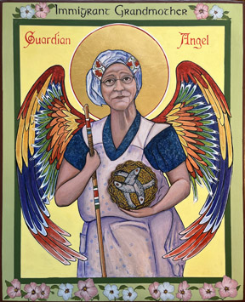
Immigrant Grandmother Guardian Angel
By the hand of Cheryl Liske, OP
Completed February 2025
12”x 14” Egg Tempera on repurposed Gessoed Board

Blessed -
In possession of -

I never really knew my grandmother, my mother’s mother. My mother was the youngest of seven and so she was basically raised by her older sisters. Her mother never learned much English and my mother never learned much of the Slovenian/German mix her mother spoke.
Grandma lived with my never-married aunt Kelly. We went to their house on Easter where my grandmother made “potica,” the traditional sweet bread from Slovenia. Even on Easter she wore an apron over her simple cotton house dress. Her head always wrapped in a scarf. I have a black and white Kodak photo of her from 1955 from which I took this image of her. She standing in a wooden row boat holding a fishing rod dressed in her apron, house dress and head scarf. There was a treadle sewing machine in the back bedroom of their house and I wonder, now if she made both dress and apron herself. My mother was a seamstress, perhaps she inherited her sewing skills from her mother.
She holds three fish in a basket – a drawing my mother taught me when I was very little. She told me her mother taught her this simple drawing of three fish in a basket starting with the letter “Y” in a circle. (Can you see the “Y”?)
My grandmother and grandfather met in Ahmeek, Michigan after emigrating from Vir in Slovenia. Ahmeek in the early 1900’s had one of the largest cooper mining operations in the country and employed many immigrants to this country. My Grandfather was a carpenter and probably built furniture and houses for the mine workers and managers. Ahmeek was the scene of violent labor unrest in 1913 -1914 when my grandparent’s first child was born. By the 1920 census they had three children. Family lore has it that a fourth child, a girl died in a snow storm while in northern Michigan. By 1924 when my mother was born they already had moved to Detroit. I gave my grandmother a walking stick to symbolize her birth in the mountainous region of Slovenia and to remember she and so many immigrants/migrants have to “keep on walking (moving)” in order to survive.
The icon is rimmed by Rose Sharon blossoms. We had a Rose of Sharon in the backyard when I was growing up. My mother would create cloths pin dolls for me using the peddles of the Rose of Sharon as the dolls skirt – another skill she learned from my grandmother.

