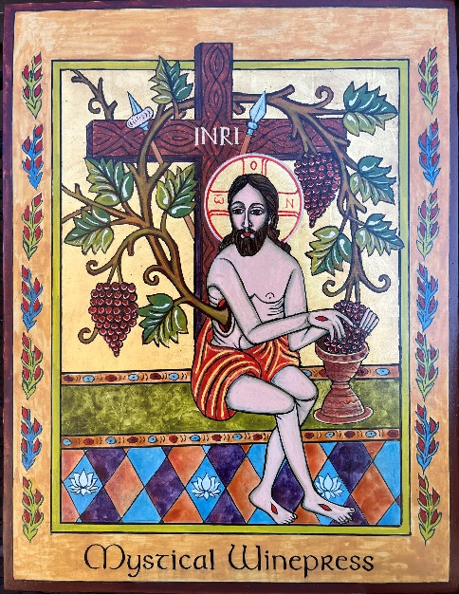

Mystical Winepress
After Romanian Glass Art Folk Art
By the Hand of Cheryl Liske, OP
Completed October 2025
12”x 14” Egg Tempera on Gessoed Board
Blessed
In possession of the iconographer

This icon of the “Mystical Winepress” is from a photo taken by Cheryl at a guest house in Iasi (Yash), Romania while on pilgrimage there in May 2006. The original is a Romanian reverse-glass icon is signed by the artist, Maghull Florian M. Hieulo
The following description of reverse glass folk art is from the website “Collection of Sacred Art” - http://sacredartpilgrim.com/
“Glass iconography may be identified nowadays with Romania, but the technique originally came from Bohemia and Austria about the time when Transylvania was annexed by the Habsburg Empire in the late 17th century. Long oppressed by Roman Catholic and Protestant landlords of Hungarian and German extraction, the Romanian peasants always remained loyal to their Eastern Orthodox faith and found ways to adapt this relatively cheap art form of their Austrian rulers to suit their own iconographic needs, turning out affordable sacred images on glass to be sold at farmers’ markets and by traveling peddlers.”
(Indeed, I purchased a small reverse glass icon of the Theotokos from a “merchant” sitting on a street corner somewhere in Transylvania.)
The parish I currently attend is the parish where I was baptized as a baby. The church itself was built in the early to mid 60’s when I was in grade school there. What can I say. It was the 60’s and to this day it looks like a big beige barn. Even the statues are beige. The windows however are a different story. The colors are vivid and the glass work superior. Unfortunately, the imagery for the most part seem to be from a second grade religion book. I say second grade because that is when students of the time made their first communion. And the images are of priests hands, hosts, chalices and the eucharist is imaged as salvation from the flames of the afterlife.
No “mysticism” in the eucharist imaged in my church windows. Just cold hard facts.
That’s why I like the “Mystical Winepress.” The image is so bizarre and strange to this child who grew up with second grade images.

