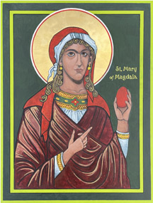

St. Mary of Magdala – Mary’s Miracle
By the Hand of Cheryl Liske, OP
Completed December 2025
12”x 16” Egg Tempera on Gessoed Board
Blessed
In possession of the iconographer

https://www.cbeinternational.org/resource/mary-magdalenes-miracle/
There is an old story that the tradition of painting Easter eggs red, originated with Mary Magdalene. She boldly appeared before Emperor Tiberius and declared, “Christ is risen!” Tiberius gestured to an egg she held and said, “Christ has no more risen than that egg is red.” Immediately, the egg turned red as a miraculous sign to show the truth of her testimony.
While this story is well-known to Eastern Orthodox Christians, a combination of factors may make it less familiar among Roman Catholic and Protestant Christians.
It Shows a Woman in a Leadership Role…It’s an Eastern Tradition…Painted Eggs Have Multiple Origins…
Why Does It Matter That We Know the Story of Mary Magdalene’s Miracle?
What if Mary Magdalene did appear before the Roman Emperor, testified that Jesus rose, and performed a miracle? What if this was the story we told every year to explain the tradition of Easter eggs? Would it mean Mary Magdalene was not only an apostle to the male apostles, but an apostle to the emperor? Would it change our view of women teaching and preaching before men and women in the early church? Would it show Christians today that God has endorsed women evangelists and preachers since the first century?
Mary Magdalene then went on to explain to Tiberius Caesar that the now-red egg symbolized life rising from a sealed chamber, a symbol that would have been understandable to a pagan Roman. Red is for the blood of Christ. The shell is like the sealed tomb full of life. Cracking is for the shattering of the Gates of Hades.

