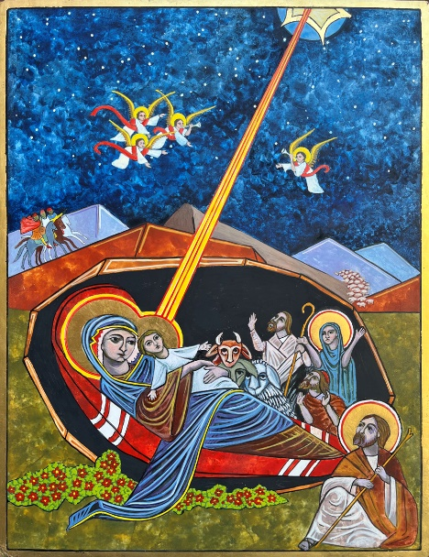

Nativity Born of Mary
By the Hand of Cheryl Liske, OP
Nearly complete February 2026
12”x 14” Egg Tempera on Gessoed Board
Blessed:
In the possession of the artist

My icon is “after” the nativity icons of the Eastern Orthodox Church, which are full of elements and symbolism not often found in western art. Something to bear in mind is that icons are images of reality – they show us how the world exists through symbol. They are not still life portraits. While they depict historical events, they frequently emphasize theology over literalness.

I call this icon, “Born of Mary” after the words of the creed and many of this icon’s elements symbolize the miracle of the incarnation, the union of earth and heaven.

The central focus is the infant Christ lying in his mother’s arms. Christ being born in a cave is not in the Bible, but it is an ancient tradition, dating back to the first and second centuries. His location in a cave foreshadows the grave in which He would be buried and where He would resurrect. The cave is also the deep womb of Mother Earth.
The cave is painted “lamp black” illuminated only by the light of heaven. A Nativity icon is what God wants to do in your soul. This is intended to be a spiritual experience.
Mary’s inner garment is brown, the color of the dust of the earth and her outer mantle is blue the color of the heavens. Her mantle spills out of the cave to touch earth which blooms into life.
In most icons Mary, the Theotokos reclines or sits on a red cushion a place of honor.
Unlike most icons that feature both Christ and the Virgin Mary, she is not looking at Him. Instead, she is looking at her betrothed, Joseph, interceding for him. The Protoevangelium tells us that after the birth of Jesus, Joseph walked out of the cave, battling doubts. Indeed, in many icons Joseph is depicted talking with the devil who is sowing these doubts. I have Joseph turning away from doubt toward the light of this new born son and hence he too wears a halo.
The other woman wearing a halo is Salome, mentioned in Mark as present at the crucifixion and as one of the Myrrhbearers, the women who found Jesus’ empty tomb. Tradition names Salome as one of the midwives at Christ’s birth.
Jesus, is being affectionately gazed upon by an ox and ass. Why those two animals? Because the church fathers read Isaiah 1:3 into the scene, which says, “The ox knows its owner and the donkey its master’s crib.” Earth and all her creatures and know to whom we belong.
The starry semicircle at the top represents the heavens. A beam of light descends from it onto Christ, confirming his divine paternity. On either side, from behind the rocky hills, angels rejoice, bringing glad tidings of the birth.

