Madonna of San Sisto (St. Sixtus)
also known as Maria Advocata (Mary our Advocate)
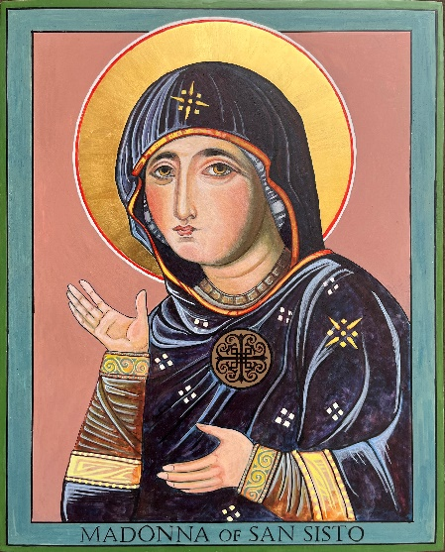 | 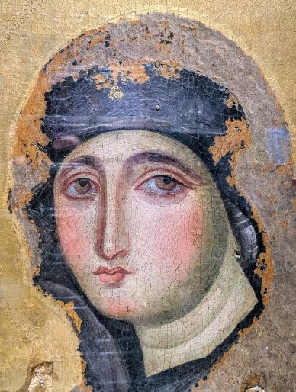 | 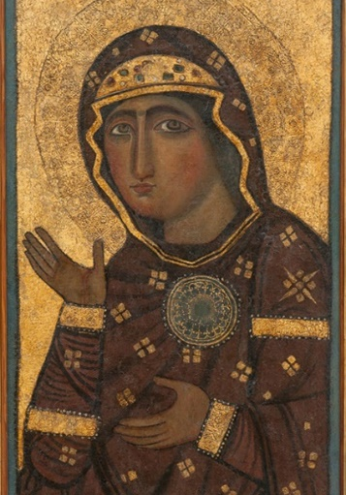
Madonna of San Sisto by the hand of Cheryl Liske, OP | Madonna of San Sisto, Photo by Lawrence Lew, OP | Madonna di sant'Alessio
After the Madonna of San Sisto and the Madonna di sant'Alessio, dating from the 12-13th centuries;
14”x 18” Egg Tempera on Gessoed Board; By the hand of Cheryl Liske, OP; Blessed: ______; In the possession of: _____

Thought to be one of the oldest icons in Italy for three reasons. 1. The Painting Technique - The “Advocata” is painted with wax, that is: “encaustic,” an ancient painting technique with hot wax and resin. Very few encaustic icons have survived, and all of them predate the 6th century because the technique was subsequently lost. 2. The Image: the face resembles some mummy portraits from the 1st to the 4th century found in Upper Egypt, all painted in the manner of the Encaustic. The oldest of these mummy portraits is closest to “Advocata” with her eyes as deep as wells. 3. The Iconic Imagery: Michael Hesemann in “Mary of Nazareth” (Ignatius Press, 2016) suggests that the icon in fact predates 431. In that year, the Council of Ephesus had defined the dogma of Mary as Theotokos, God-bearer or Mother of God. Henceforth icons of Mary would be painted with Our Lady bearing the infant Jesus in her arms. The Advocata, rather unusually, depicts Mary by herself. Thus, it seems to be earlier than the Council of Ephesus.
The story – While in Rome, St. Dominic was tasked by the pope of forming a “reformed” monastery of Nuns. Dominic renovated St. Sixtus to include a strict enclosure for his monastery. He recruited four of the nuns from Prouilhe for whom he had written the rule for the nuns and set about negotiating with the Abbess of Santa Maria in Tempulo to convince her to move her nuns to St. Sixtus. The Abbess was a shrewd negotiator, and Dominic a spirit filled preacher, finally there was but one remaining obstacle to the move to St. Sixtus. The miraculous icon of the Virgin Mary, “greatly beloved of the Romans, a focal point of piety for the community. It is said that this icon had always refused to allow itself to be place elsewhere. Carried off to the Lateran in former times, it had come back to Santa Maria, flying through the window like a bird.” (Vicaire p 347). It was agreed that the icon would accompany the nuns to St. Sixtus but if the icon refused to remain there the nuns would be released from their vows and allowed to return to Santa Maria. Dominic accepted these conditions. But in order to minimize unrest in the city, the icon was transferred in a night time, torch-lit procession. In Spring of 1221, Dominic with some of the brethren, all bare-footed carried the icon to its new residence at St. Sixtus where it was received by the four sisters from Prouilhe and 40 of the nuns from Santa Maria Tempulo.

