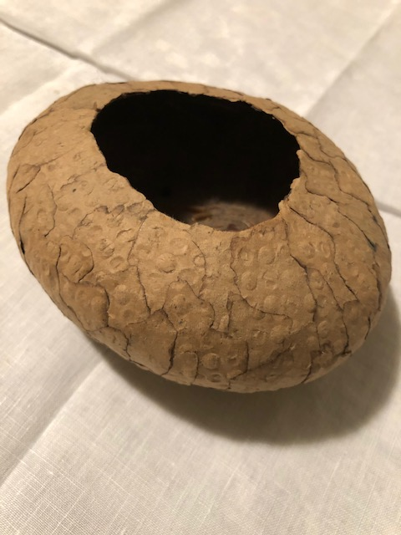

A Story about Reconciliation and Healing in South Africa
Sister Sheila Flynn
With 30 women from Sudan (15 from the north, 15 from the south)

The Sudan (North and South) have experienced 200 years of devastating civil wars where crimes against humanity have been endless, widespread ethnic cleansing, burning villages, looting, starvation, gang rape. The world remains virtually silent on this. Food was often used as a weapon; fighting over water sources, oil and other natural resources. The divisions between an Islamic State control in the North and predominantly Christians in the South, has been fierce and ongoing. Every family on both sides have experienced endless and shocking losses, murder, betrayal.

Into this reality I was asked to run a workshop with 30 beautiful women from the two sides (North and South Sudan) who came to South Africa to experience through the Truth and Reconciliation Commission, how this nation - which had known generations of inhumane ethnic cleansing, brutality at the hands of the security forces towards the disenfranchised black majority – had emerged without a massive blood bath, into democracy, and if their own story could lead to healing and reconciliation.

The main material used was ordinary brown paper, the stuff of every day that you pack with, and a pencil. We would reflect deeply on what we were carrying within.

I encouraged each woman to write down three memories/stories in their own language, of the worst experiences of their suffering and trauma; every woman present had suffered extreme brutality and loss in their families. This journaling was for themselves only, not for sharing.

Then I asked them to turn the paper over and write (again in pencil, that simple tool) three ways they could imagine that would help them take a step towards healing and forgiveness, towards hope for the future. There was not a dry eye among us as we recognised that each of their experiences was echoed in the lives and hearts of the ‘others’ – that they were standing on common ground; there were not two sides here, but one, in their suffering.

We then tore up the brown paper – a symbol of the tearing of our hearts - and proceeded to burn the edges of these smaller pieces, symbolic of the relentless suffering through generations. These burnt pieces were then reconstituted by pasting them together around a stone, emerging then as an ‘empty’ container, a vessel, to hold hope into the future (see sample above). This became a fragile shell containing the fragments of their lives, and their hopes. This was a cathartic experience for these women, processing the collective human sorrow of their lives as they struggled towards forgiveness. But it was not the end.

At a closing liturgy I asked them to offer their fragile container that now held their unreadable, agonising stories and their hope of healing and reconciliation, to one of the women from the ‘other side’. This was such an incredibly difficult thing for them to do, and there was a terrible long silence that shook us to the core as slowly, they held out their fragile vessel to exchange with one another, becoming a symbol of shared hope for the difficult landscape they would need to traverse into their future. The war continues. And so do our prayers.

