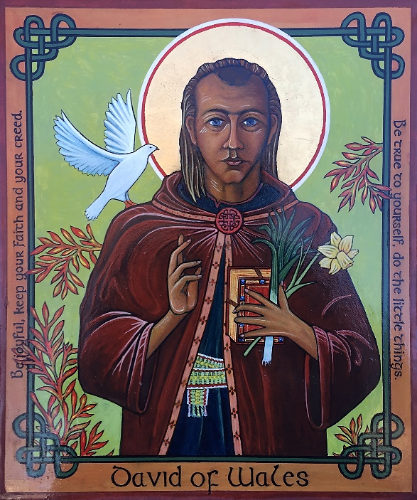David the Patron of Wales

12” W x 14” H

Completed by Iconographer,

Sister Cheryl Liske, OP

In February, 2024

Blessed at St. Suzanne Our Lady Gate of Heaven on March 3, 2024

Gifted to Cheryl’s nephew David McDermott

St. David is believed to have been born near the present-day city that bears his name, in Pembrokeshire, South West Wales. The exact year of his birth is unknown, with estimates ranging from 462 to 515 AD.

According to tradition, St. David was the son of King Sant of South Wales and St. Non.

His mother is said to have given birth on a cliff top in the middle of a violent storm. The birthing process was said to have been so intense and fraught that her fingers left marks as she grasped a rock. As David was born a bolt of lightning from heaven is said to have struck the rock, splitting it in two.

Soon after reaching adulthood, David was ordained a priest. He worked first in Wales and later in the west of England and in Brittany, and is also believed to have visited Rome and Jerusalem. He is said to have founded 12 monasteries in southern Wales during his travels.

David believed in a simple life. His monks rose at dawn to pray, and afterwards worked the fields around the monastery. They had to pull the ploughs themselves without the help of animals, and prayed as they worked. A vegetarian who ate only bread, herbs, and vegetables and who drank only water, David became known as Aquaticus or Dewi Ddyfrwr (the water drinker) in Welsh.

It is said that during a battle against the Saxons, David advised his soldiers to wear leeks in their hats so that they could easily be distinguished from their enemies, which is why the leek, along with the daffodil, is one of the emblems of Wales! The adoption of the daffodil as a national emblem is more recent and it may be that during the Victorian era, a common vegetable such as the leek was not considered glamorous enough to be the Welsh national emblem and the daffodil, whose flowering coincides with the Welsh patron saint’s holiday, seemed like a fitting replacement.

The most famous story relating to St David occurred as he preached to a large crowd at the synod of Llandewi Brefi. One of the crowd shouted, "We won't be able to see or hear him". The ground David stood on is said to have risen up so that he was standing on a hill, so he could be seen and heard by all. (Ok - Just what Wales needs is another hill!) St David is often shown with a dove on his shoulder. The bird symbolizes the Holy Spirit which gave David the gift of eloquence as he preached.

David's last recorded words appeared in a Sunday sermon. His chronicler, records the words as "Be joyful, and keep your faith and your creed (be true to yourself). Do the little things."

David is said to have lived for over 100 years, and died on Tuesday 1 March 589. His feast day is March 1st.

As a Celtic saint I have pictured him with a border of Celtic knots and with a Celtic knot closing his robe. The Celtic tonsure shaves the front of the hair leaving the back to grow long. His belt is or crios (pronounced kriss in Gaelic) is woven from wool of six colors and is so long it is wrapped more than once around the body with one end left hanging and the other tucked into the multiple winds. It has no knots, ties or clasps but is simply held in place by itself. Blue crystals of Azurite, which is found in the mines in Wales, decorate his bible.