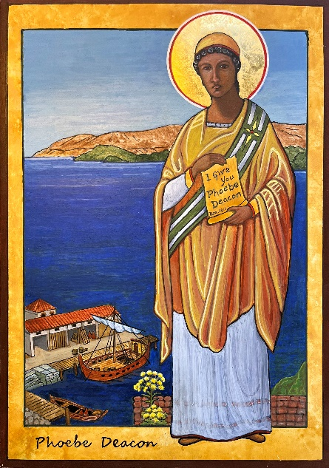Mounted photos of the icon of

St. Phoebe, Deacon

Icon by Cheryl Liske, OP

Original is 10”w x 14”h

Egg Tempera on board

Completed Spring of 2024

Original in the possession of the Adrian Dominican Sisters

Adrian, Michigan

Phoebe appears in Paul's letter to the Romans, in which he exhorts the Romans: "I commend to you our sister Phoebe, a deacon of the church in Cenchreae.” Paul writes, "I ask you to receive her in the Lord in a way worthy of his people and to give her any help she may need from you, for she has been the benefactor of many people, including me" (Romans 16:1-2).

Calling her sister, deacon and benefactor, Paul signals that Phoebe is his co-worker in the kingdom. He has chosen her to convey his message to the church in Rome, and it is his hope that they, like her, will come to believe and to support the Christian mission. By identifying Phoebe as a deacon, Paul indicates that she was a preacher and teacher of the faith and gives us the earliest written record of women's ministry in the church.

Phoebe was probably a Gentile Christian from the Greek port city of Cenchreae, a popular stop for people traveling from Syria or Asia Minor. In recent decades, a growing number of scholars have produced significant arguments for the case that Phoebe was a woman of wealth and influence within her community. She may have been a wealthy businesswoman, perhaps owning a fleet of ships, which would explain her trip to Rome. Paul likely met her in Corinth on his second missionary trip, and in some way, she had been of special help to him.

I have pictured Phoebe at the port in Corinth about to embark on her trip to Rome. She carries Paul’s letter. At her feet is the golden flowered “miracle” plant, Silphium, once the most sought-after product in the Mediterranean for its medicinal value. It was thought to have become extinct two thousand years ago but has recently been re-discovered in Turkey.

I include the “miracle plant” in my icon of St. Phoebe because female Deacons, while once highly valued in the early church are now thought to be extinct in the west. It is the prayer of many women and men today that the Deaconate for Women will be rediscovered to re-invigorate the preaching mission and ministry of the church.

Her important role in early Christian history has been retained in the traditions of many Orthodox churches in a Troparion (a short hymn celebrating a saint which is used in the daily office and liturgy): “***Enlightened by grace and taught the Faith by the Chosen vessel of Christ, You were found worthy of the diaconate; And you carried Paul’s words to Rome. O Deacon Phoebe, pray to Christ God That his Spirit may enlighten our souls!”***

St. Phoebe’s feast day is September 3.