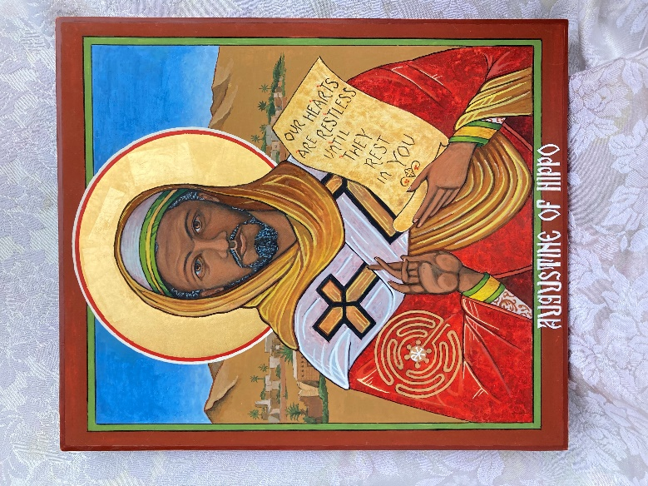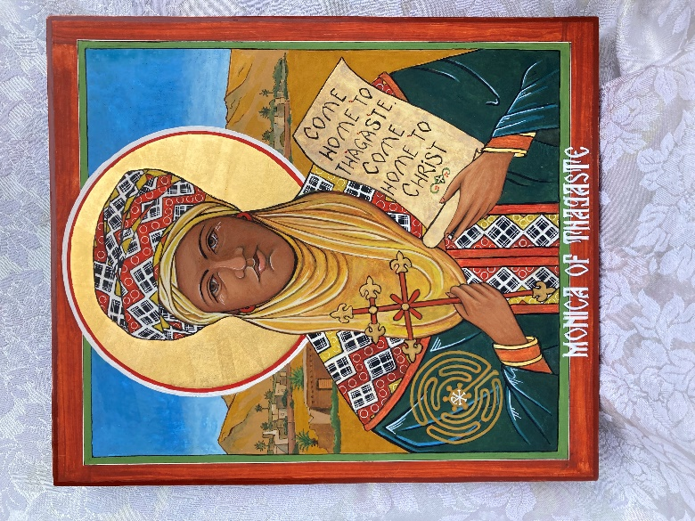

Icons of

St. Monica and St. Augustine

Both are 12”W x 14”H

Completed by Iconographer

Sister Cheryl Liske, OP

August, 2023

Blessed at St. Suzanne Our Lady Gate of Heaven September 10, 2023

On loan to St. Suzanne Our Lady Gate of Heaven

**St. Monica** (born 331) was raised in the small town of Thagaste in modern day Algeria. Thagaste had been Christian for over 250 years by the time Monica was born.

**St. Augustine** (born 354) credited Monica with planting the seeds of faith in his heart. He called his conversion a return to the faith which had been instilled in him as a child. When Augustine and his friends would get together for philosophical discussions, Augustine would invite his mother to join them. Her wise comments helped nurture the faith that had begun to grow in Augustine's heart.

It is said that all story lines in the world can be reduced to just a few. One of those is “coming home.” Saint Monica’s life was dedicated to getting her son back to his home, and to Christ. She wept, she prayed, she fasted.

During her prayers over Augustine, Monica had a vision. She was standing on an instrument used to guarantee the straightness of Roman roads. A bright, glowing “being” told her to dry her eyes, for “your son is with you.” Monica told Augustine about the vision. He responded that yes, they could indeed be together if she would just abandon her faith. Monica immediately retorted: “He didn’t say that I was with you. He said that you were with me.” Augustine never forgot her quick and insightful answer. The seed of her prayers bore fruit when Augustine abandoned his sinful life, was baptized, and decided to return to North Africa as a Christian leader. Her son had come home to the Church and was returning to his native land.

My icons have St. Monica holding the words to her prayer for her son – Come home to Christ - and St. Augustine holds the lesson he learned through all his restless seeking – “Our hearts are restless until they rest in you.” These words are the inspiration for the refrain in composer Steve Angrisano’s song - A Rightful Place.

Let us live our lives so that all might see  
That our hearts are restless till they rest in thee.

Both icons contain the image of a labyrinth. I think of this image as a symbol for “seekers” – for there are many twists and turns but only one destination – to live in Christ. Thagaste is the imagined background for each icon. St. Monica’s Feast Day is August 27th and St. Augustine’s is August 28th.